mon. | Tues. | WeD. | thurs. | friday
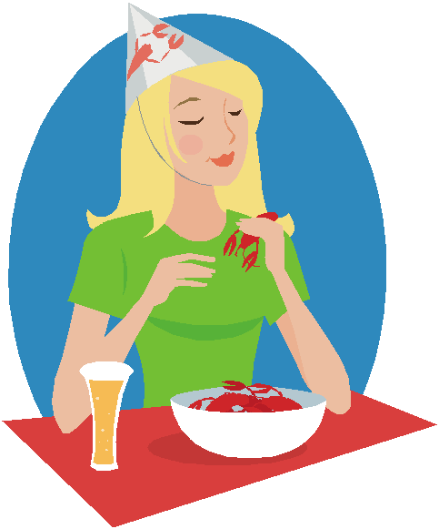 | 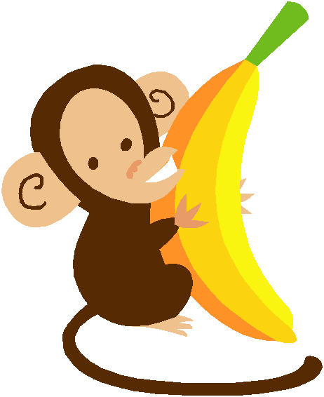 | 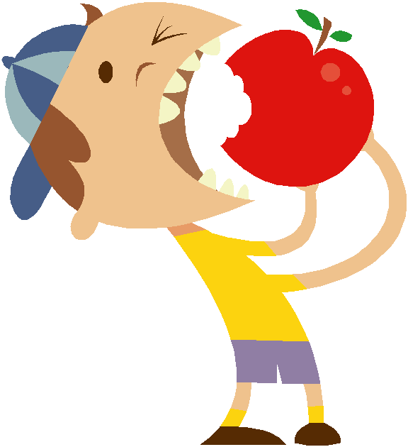 | 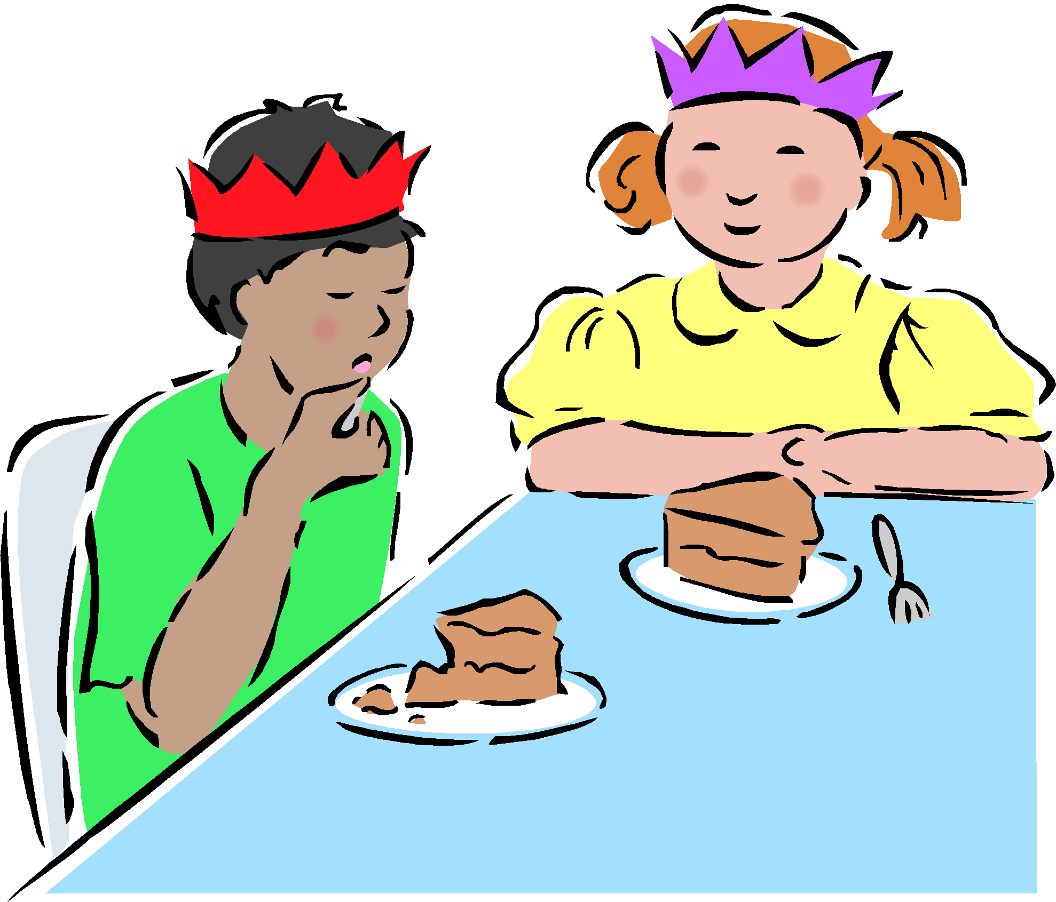
Breakfast | Breakfast | Breakfast | Breakfast | Breakfast
RICE CHEX CEREAL  BANANA  MILK  WATER | WHOLE WHEAT WAFFLES  APPLESAUCE  MILK  WATER | WHOLE GRAIN ENGLISH MUFFINS  ORANGES  Milk  WATER | PANCAKES  DICED PINEAPPLES  MILK  WATER | CORN FLAKES  BLUEBERRIES  MILK  WATER
Lunch | Lunch | Lunch | Lunch | Lunch
CHICKEN SANDWICH  SALAD  APPLE SLICES  MILK  WATER | BISCUIT  MEATLOAF  MASHED POTATOES  ITALIAN GREEN BEANS  MILK  WATER | WHEAT BREAD  BAKED CHICKEN  SWEET POTATO FRIES  SLICED PEACHES  MILK  WATER | CHICKEN ALFREDO  CORN  MANDARIN ORANGES  MILK  WATER | BEEF NACHOS  PINTO BEANS  SLICED APPLES  MILK  WATER
 | 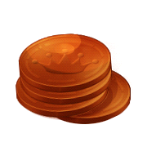 | 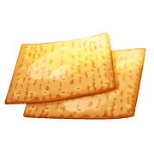 | 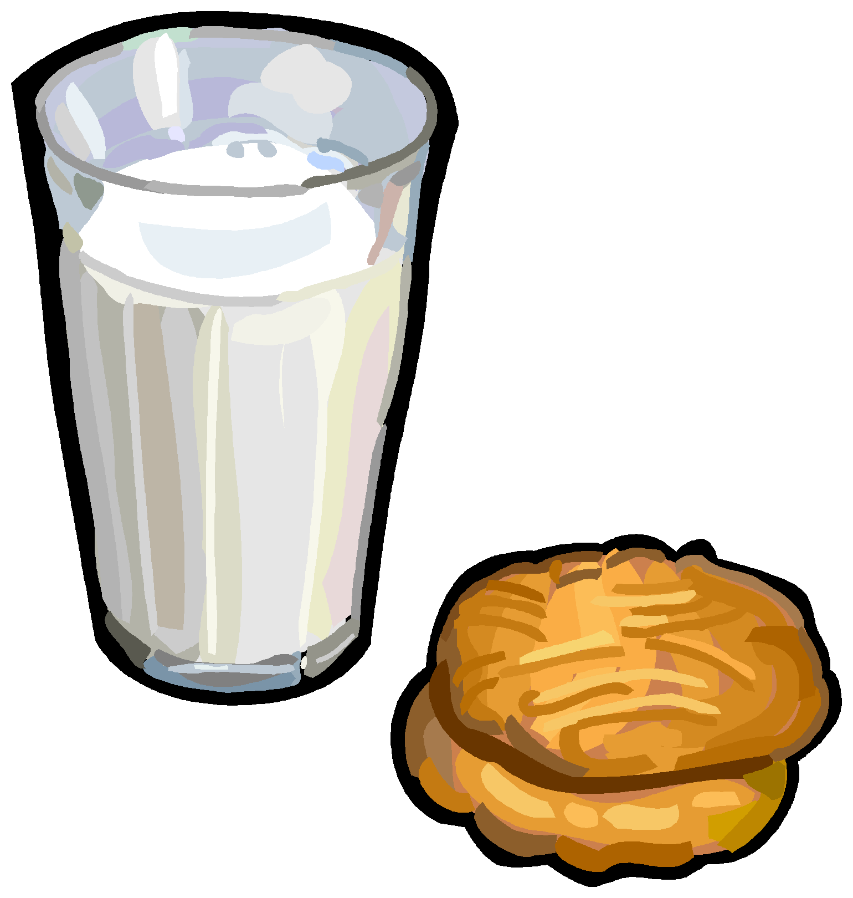 | 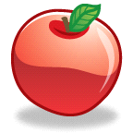
PM Snack | PM Snack | PM Snack | PM Snack | PM Snack
VEGGIE CHIPS  GRAPES  WATER | APPLES  PEANUT BUTTER  WATER | CHEESE QUESDILLAS W/ RED BELL PEPPER  WATER | CARROTS  PEANUT BUTTER CRACKERS  WATER | MANDARIN ORANGES  MINI RICE CAKES  WATER
Supper | Supper | Supper | Supper | Supper
STEAK FINGERS  SPINACH  SLICED PEARS  WHEAT BREAD  MILK  WATER | CHEESE TURKEY BURGER  FRENCH FRIES  SLICED APPLES  MILK  WATER | TASTY TENDERS CHICKEN STRIPS  COLLARD GREENS  APPLESAUCE  MILK  WATER | CHEESE PIZZA  SALAD  FRUIT COCKTAIL  MILK  WATER | TURKEY AND CHEESE  SANDWHICH  CUCUMBERS  PICKLES  MILK  WATER

